**SQL Results for Queries**

**Question 1:** List the following details of each employee: employee number, last name, first name, sex, and salary.

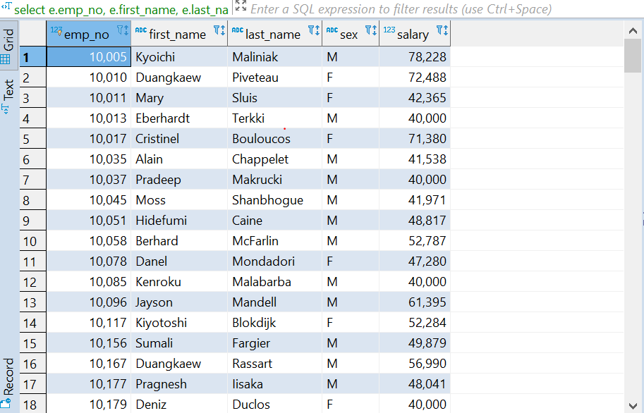

**Fig 1:** Employee details

**Question 2:** List first name, last name, and hire date for employees who were hired in 1986.

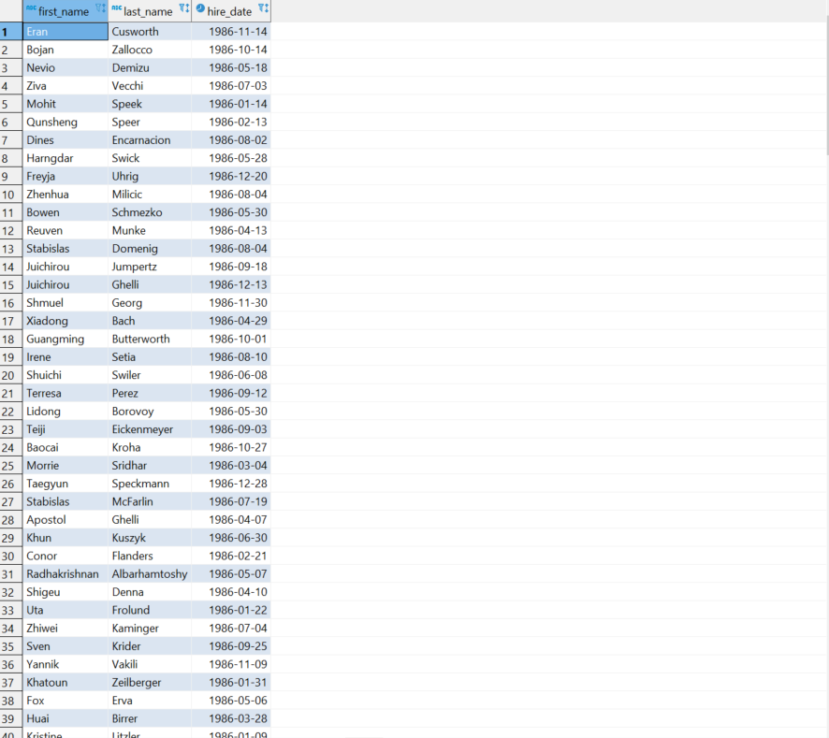

**Fig 2**: employees hired in 1986

**Question 3:** List the manager of each department with the following information: department number, department name, the manager's employee number, last name, first name.

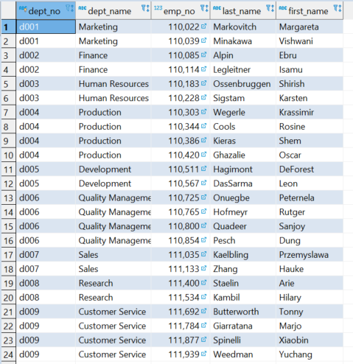

**Fig 3**: Managers of Departments

**Question 4**: List the department of each employee with the following information: employee number, last name, first name, and department name.

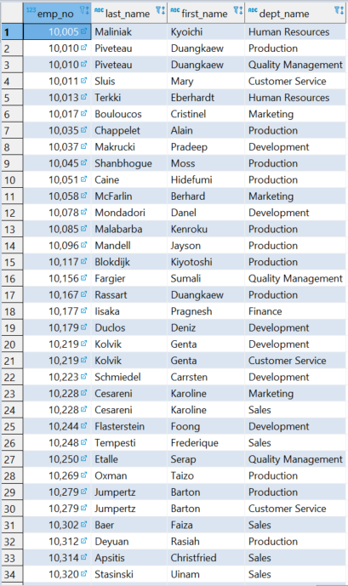

**Fig 4**: Employees and departments

**Question 5:** List first name, last name, and sex for employees whose first name is "Hercules" and last names begin with "B."

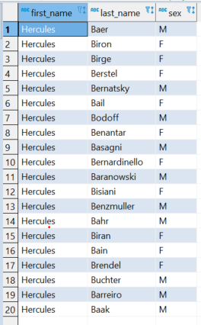

**Fig 5**: Employees with the name Hercules

**Question 6**: List all employees in the Sales department, including their employee number, last name, first name, and department name.

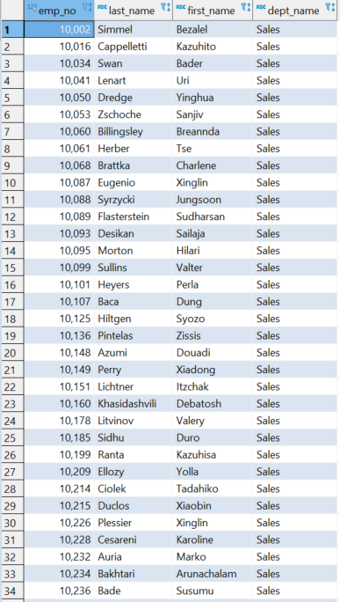

**Fig 6:** Employees in Sales Department

**Question 7**: List all employees in the Sales and Development departments, including their employee number, last name, first name, and department name.

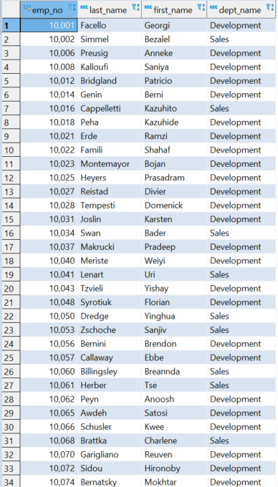

**Fig 7:** Employees in Sales and Development

**Question 8:** In descending order, list the frequency count of employee last names, i.e., how many employees share each last name.

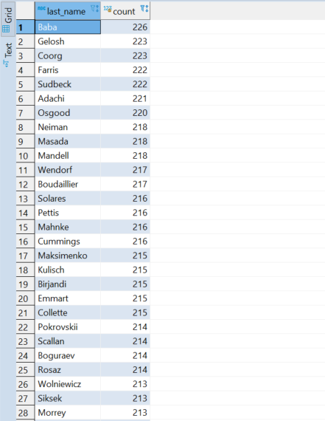

**Fig 8:** Frequency of last name of employees in descending order